1. 

A Comprehensive Analysis of Financial Performance: Insights of a Leading Banks

**Project by:**

N.Nandhini

G. Nishanthini

S. Praveena

N. Sangavi

**Team ID : NM2023TMID06712**

**Introduction:**

A financial performance analysis examines the bank at a specific period in time-ususally, the most recent fiscal quarter or year. The balance sheet, the income statement, and the cash flow statement are three of the most significant financial statements used in performance analysis.

The purpose of this project is to create to know about the total assests of the leading banks in the world.

**Problem Definition & Design Thinking:**

*Empathy map*

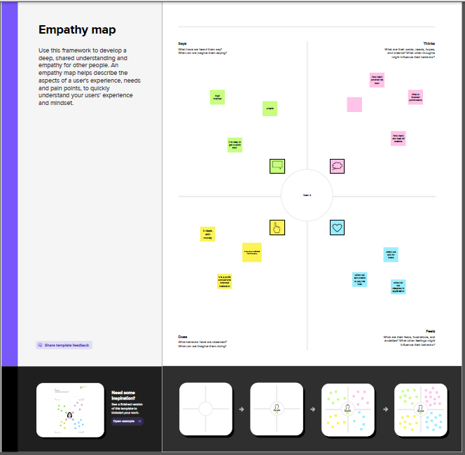

*Ideation & Brainstorming Map:*

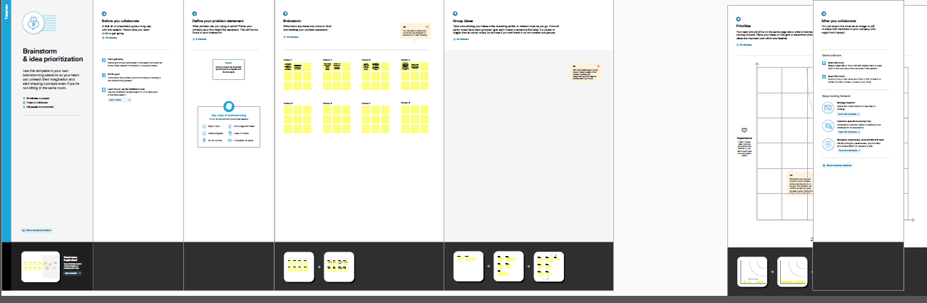

**Result:**

*Top 25 banks according to total assests*.

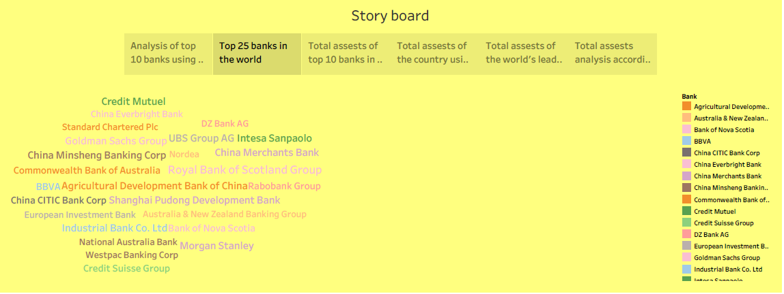

The above picture is used to understand the assests of the banks by using word cloud. Royal Bank of Scotland Group in UK has the highest total assests compared to the top 25 banks in the world.

*Top 10 banks according to country based on total assests.*

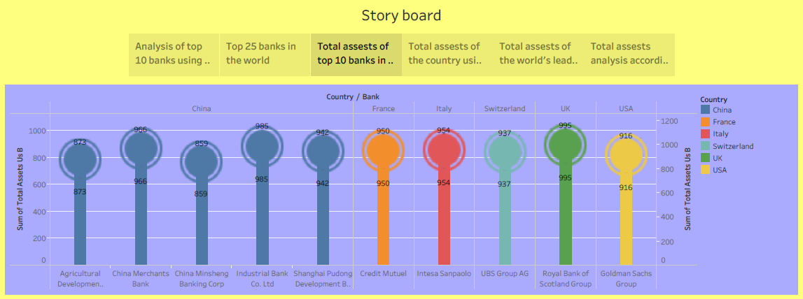

There are 5 leading banks in China by total assests. The UK has the Royal Bank of Scotland Group with the highest total assests among leading banks.

*Total assests analysis according to year and quarter*

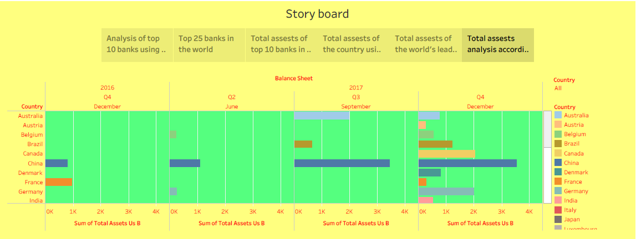

Compared to other countries, China ranks first in terms of total assests as per annual and quarterly reports. But in December 2016, France ranks first position.

*Final analysis of financial performance of leading banks*

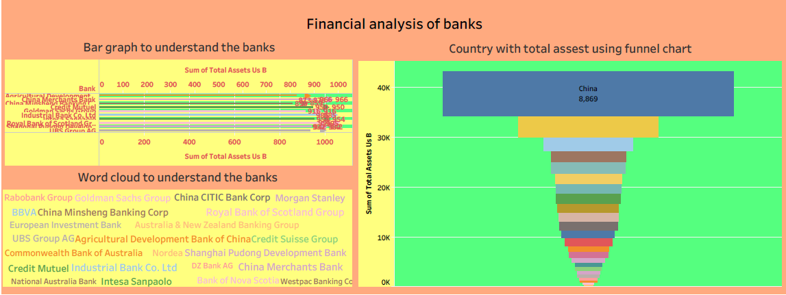

Financial performance of banks can be analyzed from the sum of total assests. China has the highest total assests and ranks first with the top 5 banks in the world. The total assests of banks can be understood from the graph mentioned above.

**Advantages and Disadvantages:**

* Stay focused on relevance. Recent trends should be taken into consideration when analyzing financial information.
* It provides financial information such as assests, bank’s revenue, expenses, profitability and debt.
* Measurements problems and a short-term concentration are two drawbacks of financial performance.
* The financial analysis might be ambiguous without the prior knowledge of the changes in accounting procedure followed by an enterprise.

**Application:**

The analyze of financial performance in banks tells investors about its general well-being. It is used to analyze how well the bank is doing especially identify where strengths and weaknesses lie.

It maintains liquidity, optimized financial reporting and decisions making for budget allocations. It provides internal external stakeholders with the opportunity to make informed decisions regarding investing.

**Conclusion:**

Analysis of financial statements is extremely important for every business to grow and increase their revenue. This project shows that the total assests of the world’s leading banks and analyzes the annual and quarterly reports. It is very beneficial for the financial sectors to analyze the financial statements.

**Future Scope:**

Financial analysis helps them in reviewing the investment alternatives for judging the earning potential of the enterprise. With the help of financial statement analysis, assessments and prediction of the bankruptcy and probability of business failure can be done.

By using financial performance analysis the bank can learn about the total assests and how their performance is performing. Through this, banks can know its performance in future and act accordingly.

India is ranked 60th place in terms of total assests of State Bank of India. There are 5 leading banks in China. But UK’s Royal Bank of Scotland Group is the number one bank in terms of total assests.

**Appendix:**

Analysis of Financial Performance Dashboard:

<https://public.tableau.com/views/AcomprehensiveanalysisoffinancialperformanceInsightsfromaleadingbanks2/Dashboard1?:language=en-US&:display_count=n&:origin=viz_share_link>

Analysis of Financial Performance Story:

<https://public.tableau.com/views/AcomprehensiveanalysisoffinancialperformanceInsightsfromaleadingbanks/Story1?:language=en-US&:display_count=n&:origin=viz_share_link>

Dashboard & Story with Web Bookstrap:

<file:///C:/Users/ELCOT/Desktop/A%20Comprehensive%20Analysis%20of%20Financial%20Performance_%20Insights%20from%20a%20Leading%20Banks/index.html#team>